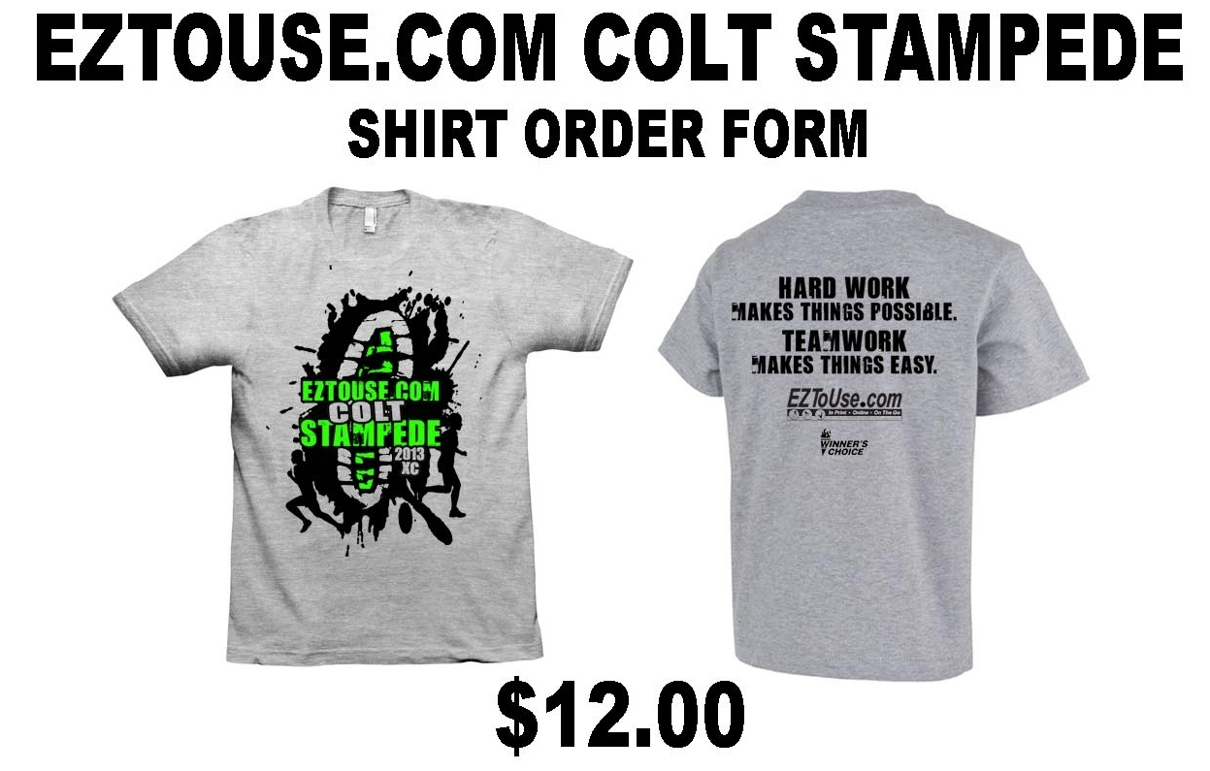
There will be a vendor on-site to heat press names on shirts for an additional fee.

- Orders must be returned to meet director by Sept 5th - to your coach by Sept 4th.
- Shirts will be paid for the day of race when you pick up at the shirt table – your coach does not need to collect money.
- Only a small amount of extra shirts will be available on day of race.

Athlete Name: _________________________________
Size: _______________________ (S,M,L,XL)
Return to Your Coach by Sept. 4th.

SCHOOL NAME:

Please check size Adult size
Athlete Name | S | M | L | XL
1.
2.
3.
4.
5.
6.

7.
8.
9.
10.
11.
12.
13.
14.
15.
EZtoUse Colt Stampede T-Shirt Summary Sheet – Please email number of each size needed or this form to coltsxc@hotmail.com by Sept 5th (by noon).

